PROJECT FINANCIAL CONTROL (PFC) WORKING PAPER
24-269112 POZ SBD MINI for POZ
Project Code: AMB20 | Prepared: Nov 05, 2026 | Total Procedures: 30

Name of Project | 24-269112 POZ SBD MINI for POZ | Project Code | AMB20
PFC Team Members | Pranali Shrimali

21  Completed | 1  In Progress | 5  Pending | 1  NA

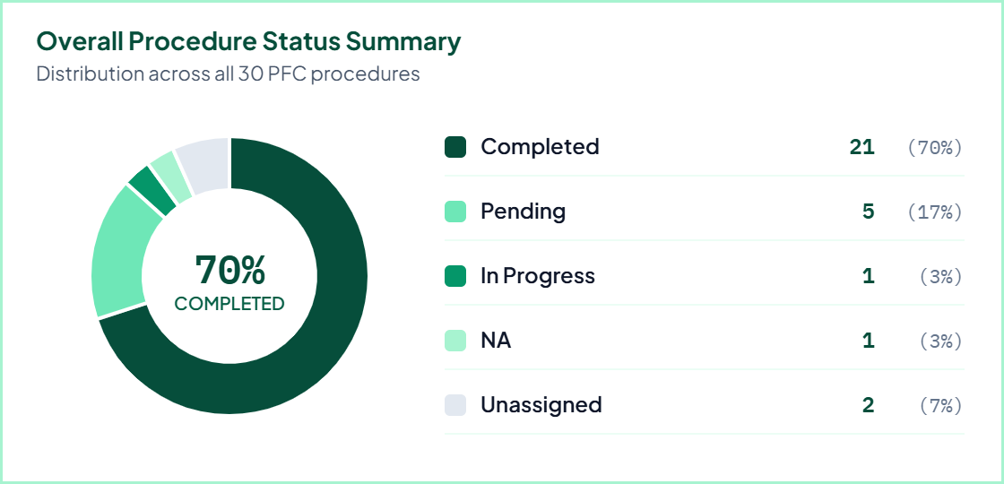
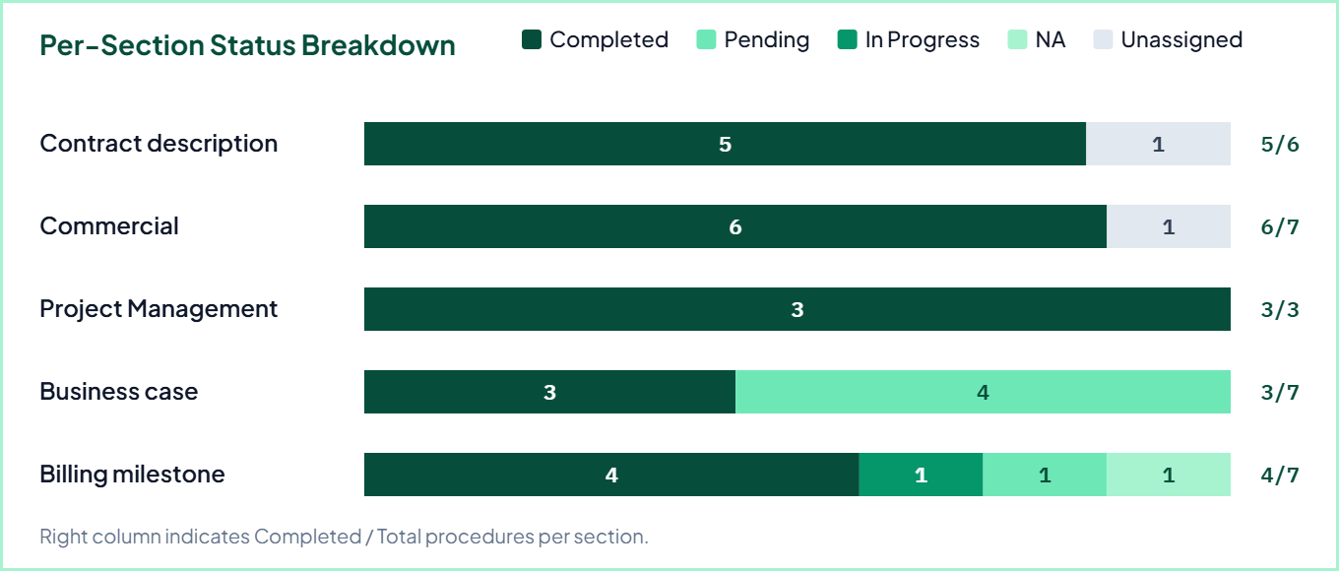

Detailed PFC Working Paper Checklist
Project: 24-269112 POZ SBD MINI for POZ (AMB20) | Team: Pranali Shrimali
1. Contract description
Section Summary: 5 Completed, 0 NA (out of 6 procedures)
Ref | PFC Procedure | Status | Team Member | Remarks
CD-01 | Scope (Requirements)  Review and document the contracted scope of work and functional/technical requirements from the agreement. | Completed | Pranali Shrimali | The POZ is planning budget for construction / expansion of the airport and based on F2F visit of CIO at POZ, they are interested to get offer for 3-5 years 4 SBD Mini with Printer Box - one step including integration of 1 airline (Ryanair) with and without payment. The offer should also include the optional integration of LOT + LH + SAS and Wizz. The offer will be used for budgeting. The competitor is Airware solution for Ryanair, thus need for speed and positioning benefits of the Common Use aspect of SITA solution. The offer is needed by 16th of September.
CD-02 | Customer Description  Document the customer profile, operational context, and key business background as per contract and business case. | Completed | Pranali Shrimali | Customer -Dimark S.A. in country Poland
CD-03 | SITA Contracting Entity as per agreement  Verify and record the exact SITA legal contracting entity named in the executed agreement. | Unassigned | — | SITA Switzerland
CD-04 | Customer Entity as per Agreement  Verify and record the exact Customer legal entity name and registration details as per the agreement. | Completed | Pranali Shrimali | DIMARK SPÓŁKA AKCYJNA
CD-05 | Known Risks and Issues (Logs)  Review contract documents and risk logs to identify and document all known delivery, commercial, or operational risks and issues. | Completed | Pranali Shrimali | NA
CD-06 | Mitigation of Risk as per BC  Verify and document the planned risk mitigation actions and controls as outlined in the approved Business Case (BC). | Completed | Pranali Shrimali | NA
2. Commercial
Section Summary: 6 Completed, 0 NA (out of 7 procedures)
Ref | PFC Procedure | Status | Team Member | Remarks
CM-01 | Warranties & Insurance  Review contractual warranty periods, defect liability terms, and insurance coverage obligations with PM and Solution Design. | Completed | Pranali Shrimali | The Customer warrants that its procedures and the decision to appoint SITA to perform the Agreement as the supplier of the Service complies with all relevant laws, regulations and any applicable guidelines. 8.3. Exclusion of Implied Warranties. SITA makes no guarantees, warranties or representations whatsoever about adequacy or fitness for purpose of the Service or otherwise.
CM-02 | Termination  Check termination-for-convenience, termination-for-cause, notice periods, and exit/wind-down commercial terms. | Completed | Pranali Shrimali | Either party may immediately terminate this Agreement by notice to the other party, if the other party commits any material breach, non observance or non-performance of a material obligations in this Agreement. 11.2. SITA may limit, suspend or cancel a Service at any time with or without prior notice to Customer if, in SITA’s sole opinion: there is an event of emergency; the supply or use of a Service is or will become unlawful; any permit or approval required for the Service to operate is or will be withdrawn; there is an actual or threatened claim against the Intellectual Property of the Service; or the provision of a Service is liable to cause or result in death or personal injury or damage to property.
CM-03 | Intellectual Property  Verify ownership and licensing rights for background IP, foreground/custom developments, and third-party software. | Completed | Pranali Shrimali | NA
CM-04 | Limitation of Liability  Confirm liability caps, consequential damages exclusions, and any uncapped indemnity carve-outs in the contract. | Completed | Pranali Shrimali | NA
CM-05 | Bonds  Identify any performance bonds, advance payment guarantees, or bank guarantees required under the commercial schedule. | Unassigned | — | —
CM-06 | Treatment of Delays Customer & SITA  Review contractual provisions governing extension of time (EOT), customer-caused delays, and SITA-caused delays. | Completed | Pranali Shrimali | If a party is unable to perform or is delayed in performing an obligation under this Agreement because of a Force Majeure Event, then: that obligation is suspended but only so far and for so long as it is affected by the Force Majeure Event; and the party affected by the Force Majeure Event will not be liable for delay or failure to perform any of its obligations in this Agreement (including if applicable in respect of Service Levels).
CM-07 | Penalties  Verify liquidated damages, SLA service credits, and milestone delay penalty clauses and maximum penalty caps. | Completed | Pranali Shrimali | NA
3. Project Management
Section Summary: 3 Completed, 0 NA (out of 3 procedures)
Ref | PFC Procedure | Status | Team Member | Remarks
PM-01 | Project Start Date  Confirm the official project start date with PM and Solution Design and verify alignment with contract effective date. | Completed | Pranali Shrimali | 1st April 2025
PM-02 | End date  Confirm the scheduled project completion / end date, including any phased handover or support tail dates. | Completed | Pranali Shrimali | 31st Dec 2025
PM-03 | Phase of Project  Document the current phase of the project (e.g., Initiation, Design, Build, UAT, Cutover, Run) and key timeline gates. | Completed | Pranali Shrimali | Only Phase 1
4. Business case
Section Summary: 3 Completed, 0 NA (out of 7 procedures)
Ref | PFC Procedure | Status | Team Member | Remarks
BC-01 | Billing Plan  Review the overall billing plan in the Business Case and reconcile total billable value with SITA commercial team. | Completed | Pranali Shrimali | One time payment Hardware - $82000, Integration of 5 additional airlines - $50000, Spares -$8750
BC-02 | Accurate contingency  Verify that project risk contingency reserves are accurately calculated, approved, and reflected in the Business Case. | Pending | Pranali Shrimali | NA
BC-03 | Assumptions in building costs / pricing  Review key cost and pricing assumptions (effort estimates, rate cards, indexation, FX) with SITA commercial team. | Pending | Pranali Shrimali | —
BC-04 | Costs (SWD, Test, 3rd Parties, Certification)  Verify completeness of all cost lines including Software Development (SWD), Testing, 3rd Party vendors, and Certification. | Pending | Pranali Shrimali | —
BC-05 | Cash Flow considerations  Assess project cash flow profile, timing of cash outflows vs. customer collections, and working capital impact. | Pending | Pranali Shrimali | —
BC-06 | CAPEX vs OPEX  Confirm classification of project expenditure between CAPEX and OPEX in accordance with SITA financial policy. | Completed | Pranali Shrimali | OPEX project
BC-07 | Revenue Recognition method  Coordinate with SITA consolidation team to confirm and document the applicable revenue recognition method. | Completed | Pranali Shrimali | Point in time. Once customer control the hardware and startes benefitting.
5. Billing milestone
Section Summary: 4 Completed, 1 NA (out of 7 procedures)
Ref | PFC Procedure | Status | Team Member | Remarks
BM-01 | Customer Code available for billing Yes / No  Check if Customer Code is available for billing (Yes/No). If No, ensure to communicate to Account Manager & GEO Business management. | Completed | Pranali Shrimali | 0000068360
BM-02 | Check Billing details in Salesforce: OTC & Recurring charges, Advance  Deep dive in Salesforce to verify OTC (One Time Charges), Recurring charges, and any Advance to be taken from customer. | Completed | Pranali Shrimali | OTC
BM-03 | Currency of contract & payment currency  Verify the currency of the contract and specify the exact currency in which customer payment will be made. | Completed | Pranali Shrimali | USD
BM-04 | Check Bank details in contract & billing reflection  Check Bank details in contract & ensure same is reflected for billing. If no details available, communicate to Account Manager & GEO Business management. | Pending | Pranali Shrimali | y
BM-05 | Billing milestones  Verify all contractual billing milestones, trigger events, acceptance criteria, and scheduled billing dates in Salesforce. | Completed | Pranali Shrimali | Pranali Shrimali did the work of Billing milestones and there were no adverse findings.
BM-06 | Concession fee (Yes/No) and amount/frequency  Confirm whether a Concession fee applies (Yes/No) and document the exact amount and billing/payment frequency. | NA | Pranali Shrimali | —
BM-07 | Periodic Reconciliation (frequency)  Establish and document the Periodic Reconciliation frequency (e.g., monthly, quarterly) and responsible owner. | In Progress | Pranali Shrimali | —

